Team members: Brennon Franklin, Ben Miller, Spas Spasov and Callum Weaver.

The task that was given to the team was to create a board game version of a videogame that players could play and that shared similarities with its videogame counterpart. This game must be easily linked to the original videogame.

The team decided to make a game based on the videogame Middle Earth: Shadow of Mordor. The game would include orcs that the player could recruit and that would be used to conquer castles and eventually capture the centre castle that players need to capture in order to win the game. The game was intended to be played by two to four players. The game would require dice in order to be played and the team wanted to include cards that would provide benefits for players.

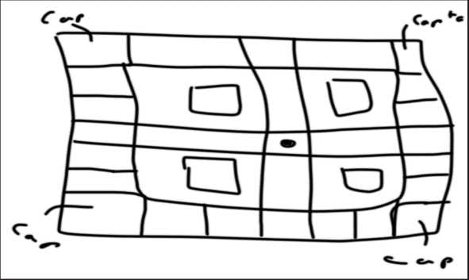

Figure 1. Basic idea for game board.

The rules that were decide upon by the team were that each player would start with 5 follower orcs and 1 captain orc. The order in which players take their turns would be decided by the roll of the dice with the highest roll going first. Players move in accordance with their roll and can go in any direction.

The game would include tiles that give players a maximum of two passives. These passives would provide permanent boosts such as increased damage for the players army or an extra turn every round. These passives can completely change the game in terms of a player’s power.

The game is similar to the videogame in terms of being able to recruit orcs to improve the players army and to take over new land. The end goal is to capture castles in order to win the game.

The battles would be fought using the orcs that the player has accumulated. Normal orcs are worth one point, captains are worth three points and warlords are worth five points. These points would determine the highest roll a player could achieve. Having between 1 and 20 points allows the player to roll a 1 or 2 on the dice, 21 – 30 allows up to a three. 31 – 40 allows up to a four, 41 – 50 allows up to a 5 and 51+ allows the max roll of a six. The players roll a die and must get between the points they can reach. If they roll higher than their max they must reroll. If a player loses a battle they must return to their starting castle.

In order to win the game a player must hold the central castle for five rounds. If they lose the castle they can recapture it but their five rounds reset.

Figure 2. Final board design

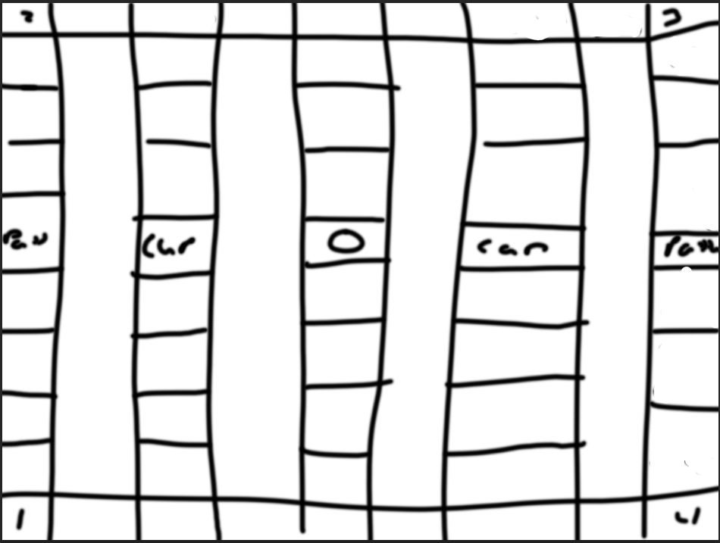

warlord

Warlord

warlord

Warlord

warlord

warlord

Warlord

warlord

Warlord

Warlord

1 troop

1 troop

1 troops

1 troops

1 troops

1 troops

captain

Warlord

Warlord

captain

captain

captain

captain

captain

captain

captain

captain

captain

captain

captain

captain

captain

captain

captain

1 troops

1 troops

1 troops

1 troops

1 troops

1 troops

1 troops

1 troops

1 troops

warlord